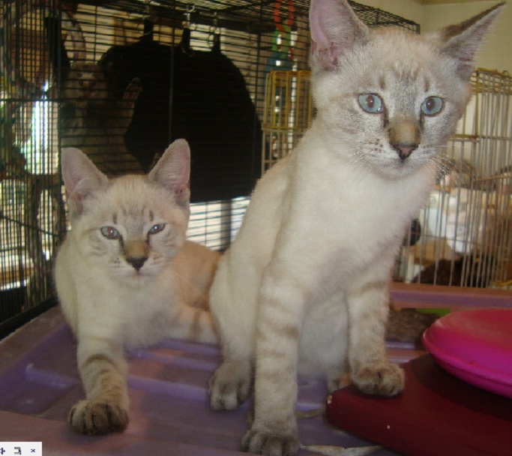
Thank you to Bianca and her Manager for ensuring these babies got to the right place, when they were dumped before they could fend for themselves, on a pavement NO box, absolutely NOTHING in the Northriding area. They have a brother, a blue tabby that does not appear in this photo. They could neither eat or drink at the time. NICE PEOPLE out there!!!!!!!!!!!!!!!!!!!!!!!!!!!!

